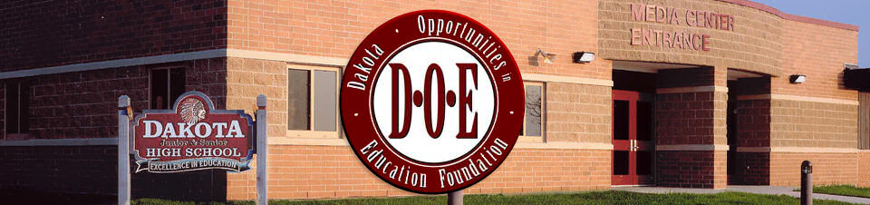

***Dakota Opportunities in Education Foundation Scholarships***

**Name: ______________________**

**Address: ______________________**

**______________________**

**Phone: ______________________**

***Dakota Opportunities in Education Foundation Scholarships***

**Eligibility**

Dakota High School Senior planning to enroll full-time in a post-high school educational program in the fall following graduation. Must have a “C” average or better. Minimum 2.0 GPA

**Directions**

Complete application and return to Kevin Cline, by Thursday, March 27, 2025. The applicant **must include** an official transcript and two letters of recommendation. I**ncomplete applications will not be considered.**

**Activities:** Include a separate sheet listing school activities, out-of-school activities and work experience. Include any leadership positions held, honors, volunteering, and awards, etc.

**Goals:** Write a brief paragraph describing your educational plans, vocational goals, and plans for community involvement (50 - 100 words).

**Statement of Qualifications:** Write an essay describing how your education at Dakota has contributed to who you are today and tell us about a special attribute and/or achievement that sets you apart (500 words or less).

**Optional:** Describe any personal or family circumstances which you feel should be brought to the attention of the selection committee.